***NAME : Himanshu Dixit***

***ENROLL NO. : B64178***

***BATCH : B10***

***Software Development Fundamentals – I (15B11CI111)***

***ODD 2021***

***Tutorial Sheet – 6,7***

***1.*** *Write a C program to count total number of positive and negative elements in an array.*

**Solution:**

#include<stdio.h>

int main()

{

int a[100],n,cp=0,cn=0;

scanf("%d",&n);

for(int i=0;i<n;i++)

{

scanf("%d",&a[i]);

}

for(int i=0;i<n;i++)

{

if(a[i]>0)

cp++;

if(a[i]<0)

cn++;

}

printf("positive = %d",cp);

printf("\nnegative = %d",cn);

return 0;

}

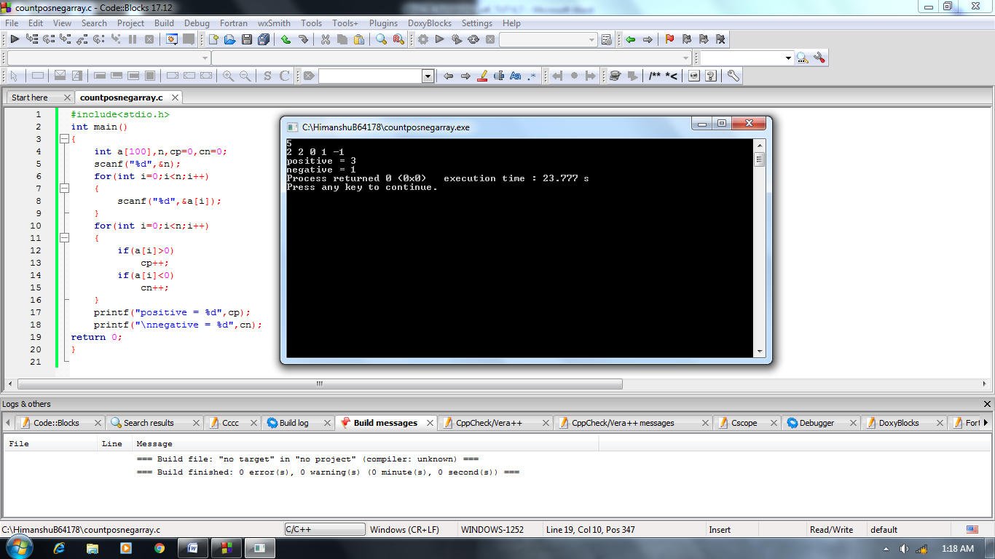

***2.*** *Write a C program to insert an element in an array. (starting, ending and mid)*

**Solution:**

#include<stdio.h>

int main()

{

int a[100],size,num,pos;

scanf("%d",&size);

for(int i=0;i<size;i++)

scanf("%d",&a[i]);

scanf("%d",&num);

scanf("%d",&pos);

for(int i=size;i>pos-1;i--)

a[i]=a[i-1];

a[pos-1]=num;

for(int i=0;i<=size;i++)

printf("%d ",a[i]);

return 0;

}

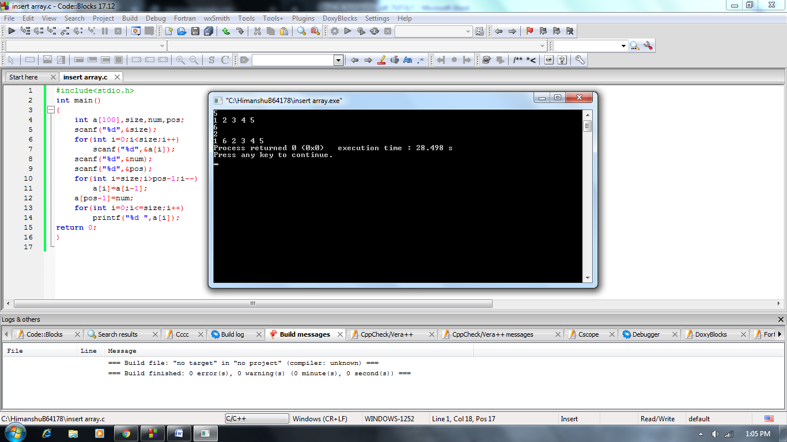

***3.*** *Write a C program to delete an element from an array at specified position.*

**Solution:**

#include<stdio.h>

int main()

{

int a[100],size,num,pos;

scanf("%d",&size);

for(int i=0;i<size;i++)

scanf("%d",&a[i]);

printf("enter the position : ");

scanf("%d",&pos);

if(pos>=1&&pos<=size)

{

for(int i=pos-1;i<size;i++)

a[i]=a[i+1];

for(int i=0;i<size-1;i++)

printf("%d ",a[i]);

}

else

printf("u have entered invalid position");

return 0;

}

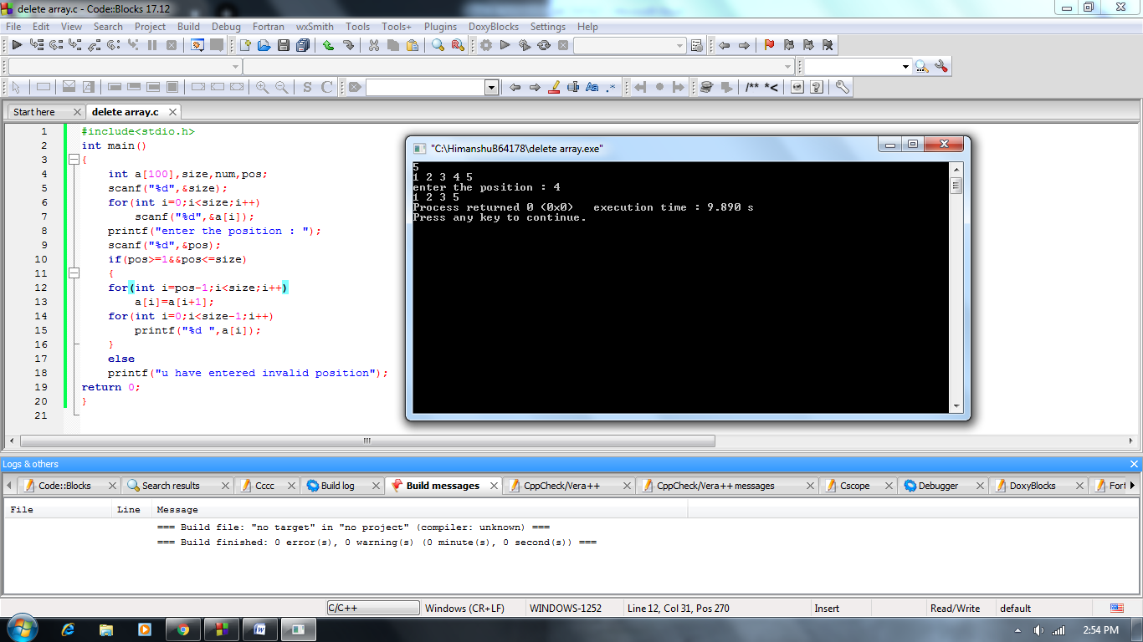

***4.*** *Consider an array arr[] which consists of n numbers. WAP to:*

***a.*** *Print reverse of the array arr[] (without using another array).*

**Solution:**

#include<stdio.h>

int main()

{

int a[100],size;

scanf("%d",&size);

for(int i=0;i<size;i++)

scanf("%d",&a[i]);

for(int i=size-1;i>=0;i--)

printf("%d ",a[i]);

return 0;

}

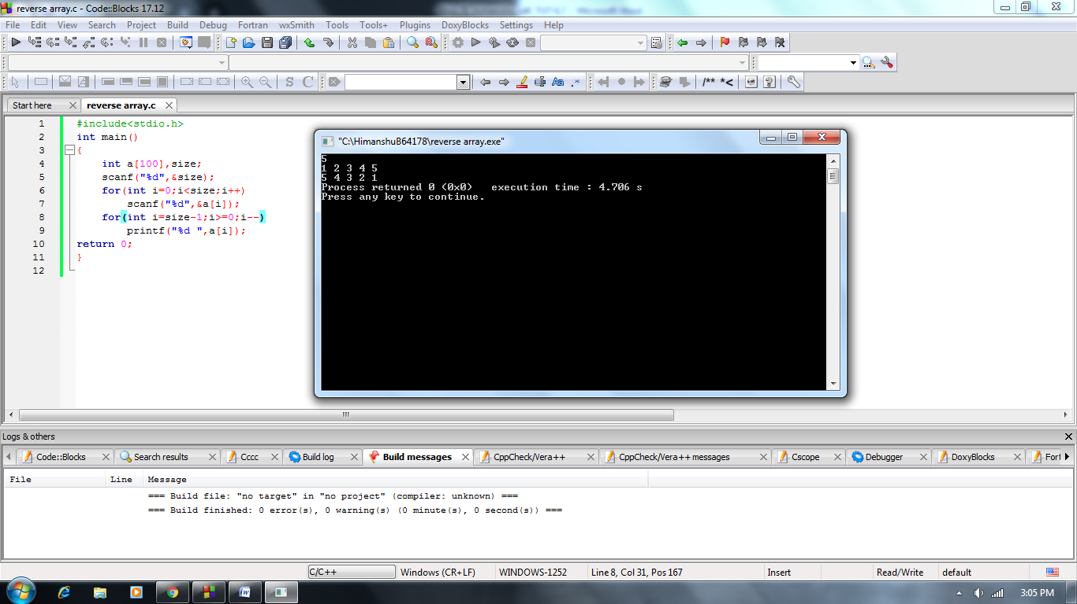

***b.*** *Store the reverse of array arr[] In another array arr2[].*

**Solution:**

#include<stdio.h>

int main()

{

int a[100],b[100],size;

scanf("%d",&size);

for(int i=0;i<size;i++)

{

scanf("%d",&a[i]);

b[size-i-1]=a[i];

}

for(int i=0;i<size;i++)

printf("%d ",b[i]);

return 0;

}

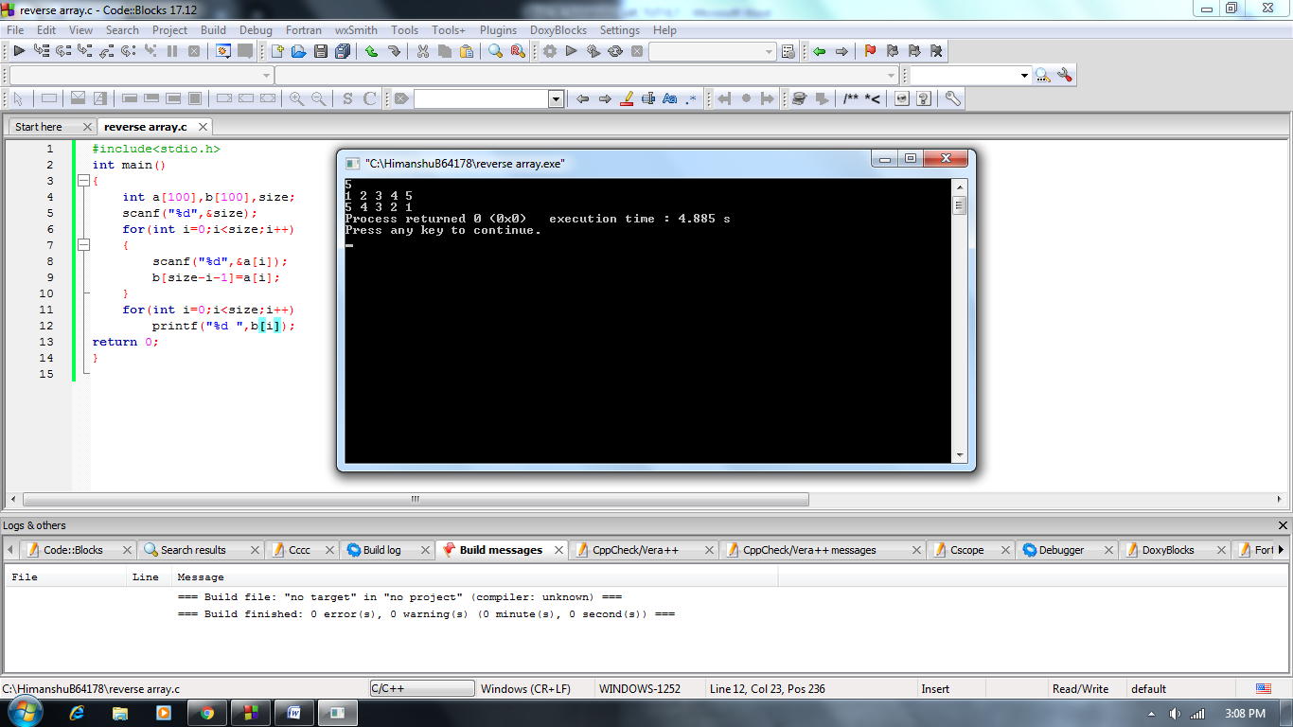

***c.*** *Reverse the array arr[].*

**Solution:**

#include<stdio.h>

int main()

{

int a[100],size,k;

scanf("%d",&size);

for(int i=0;i<size;i++)

{

scanf("%d",&a[i]);

}

for(int i=0;i<size/2;i++)

{

k=a[i];

a[i]=a[size-i-1];

a[size-i-1]=k;

}

for(int i=0;i<size;i++)

{

printf("%d ",a[i]);

}

return 0;

}

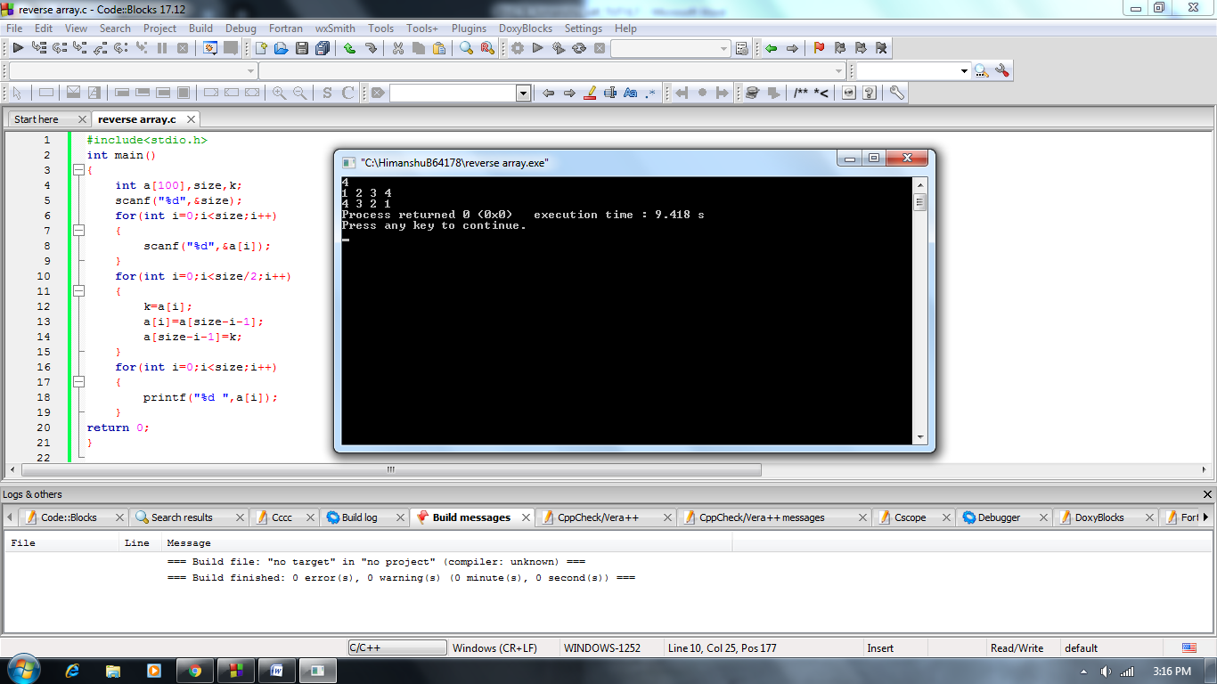

***5.*** *Consider an array marks[ ] which stores marks of n students. WAP to:*

***a.*** *Store and print marks of n students in array marks[].*

**Solution:**

#include<stdio.h>

int main()

{

int m[100],totstu;

scanf("%d",&totstu);

for(int i=0;i<totstu;i++)

scanf("%d",&m[i]);

for(int i=0;i<totstu;i++)

printf("%d\n",m[i]);

return 0;

}

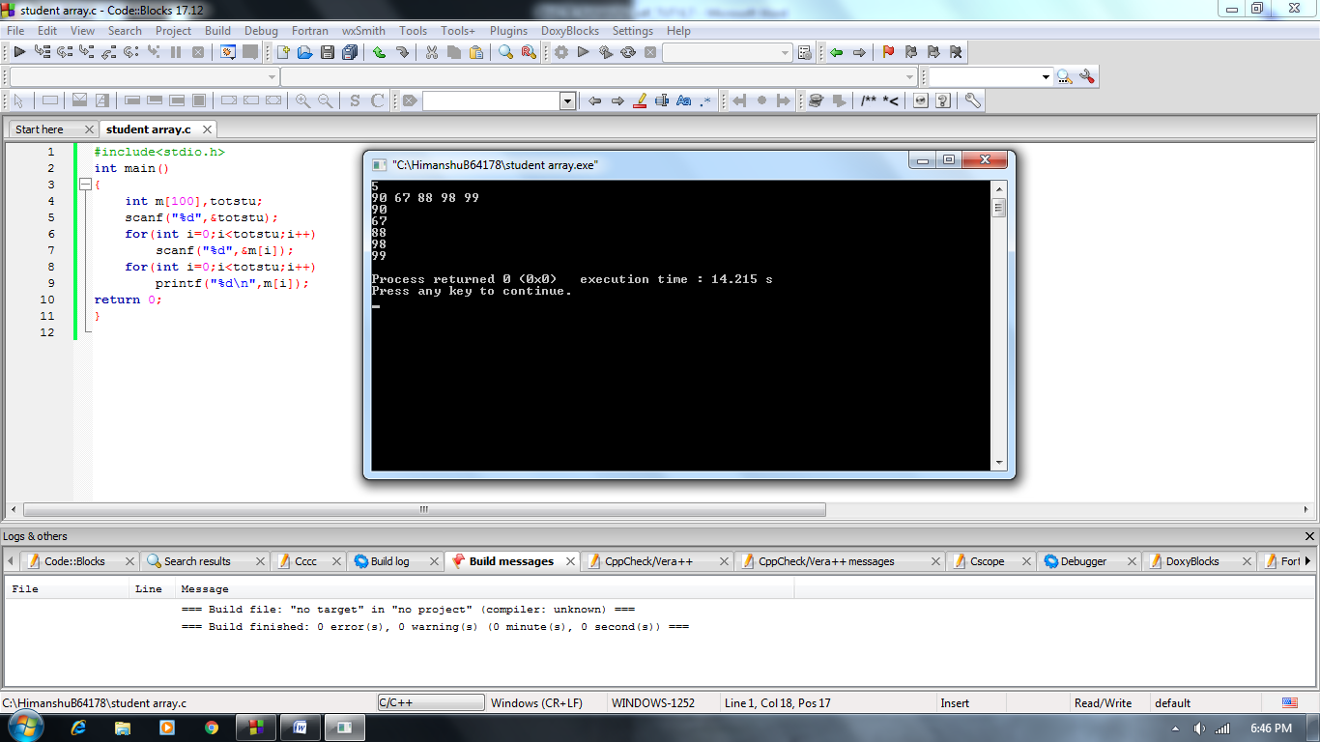

***b.*** *Find the highest and lowest marks.*

**Solution:**

#include<stdio.h>

int main()

{

int m[100],totstu,min=100,max=0;

scanf("%d",&totstu);

for(int i=0;i<totstu;i++)

scanf("%d",&m[i]);

for(int i=0;i<totstu;i++)

printf("%d\n",m[i]);

for(int i=0;i<totstu;i++)

{

if(min>m[i])

min=m[i];

else

max=m[i];

}

printf("highest %d\n",max);

printf("lowest %d\n",min);

return 0;

}

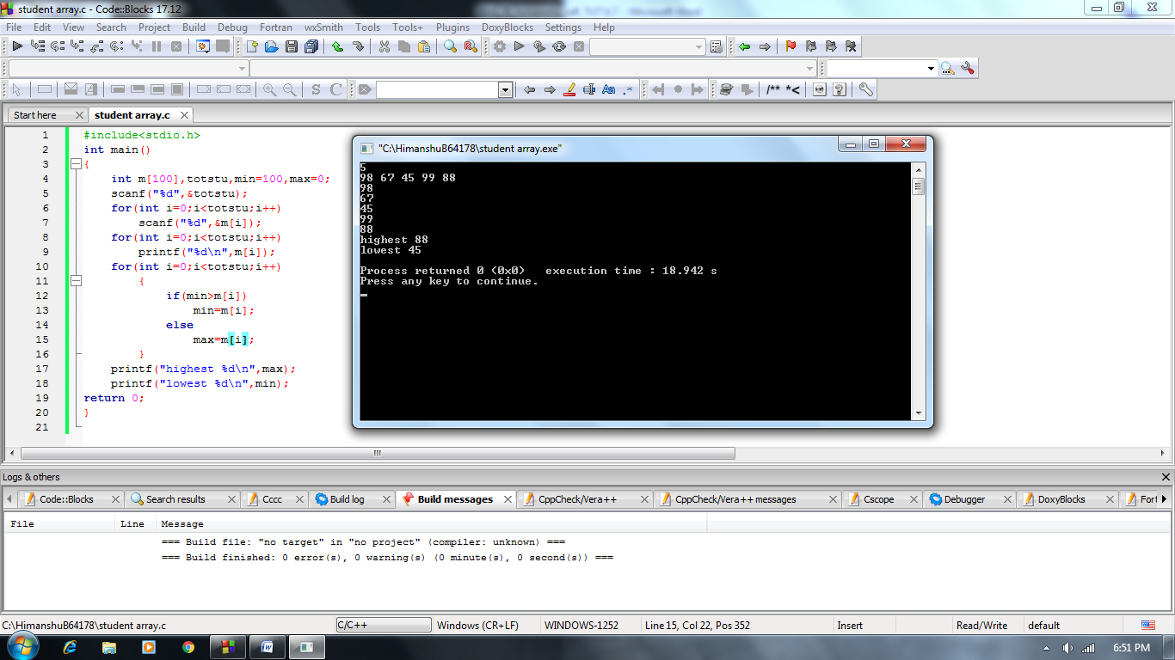

***c.*** *Find the average of marks.*

**Solution:**

#include<stdio.h>

int main()

{

int m[100],totstu;

float avg,sum=0;

scanf("%d",&totstu);

for(int i=0;i<totstu;i++)

scanf("%d",&m[i]);

for(int i=0;i<totstu;i++)

{

sum=sum+m[i];

}

avg=sum/totstu;

printf("average marks %.2f",avg);

return 0;

}

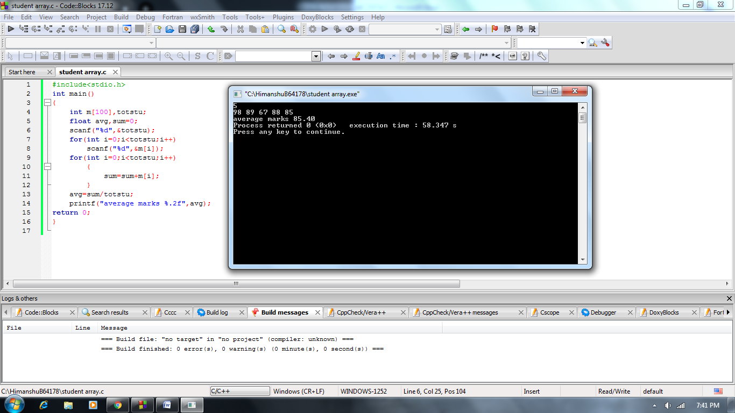

***d.*** *Find the median of marks.*

**Solution:**

#include<stdio.h>

int main()

{

int m[100],totstu,k;

float median;

scanf("%d",&totstu);

for(int i=0;i<totstu;i++)

scanf("%d",&m[i]);

for(int i=0;i<totstu;i++)

{

for(int j=i+1;j<totstu;j++)

{

if(m[i]>m[j])

{

k=m[i];

m[i]=m[j];

m[j]=k;

}

}

}

for(int i=0;i<totstu;i++)

printf("%d ",m[i]);

if(totstu%2==0)

{

median=(m[(totstu/2)-1]+m[(totstu/2+1)-1])/2;

}

else

{

median=m[((totstu+1)/2)-1];

}

printf("\nmedian %.2f",median);

return 0;

}

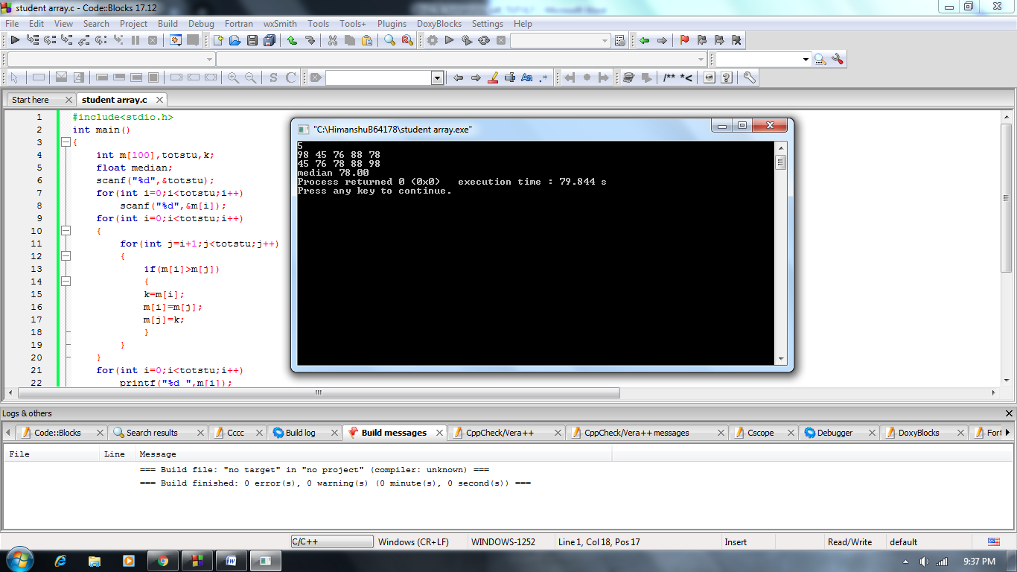

***e.*** *Find the mode of marks.*

**Solution:**

#include<stdio.h>

int main()

{

int m[100],totstu,count,c=0,k;

scanf("%d",&totstu);

for(int i=0;i<totstu;i++)

scanf("%d",&m[i]);

for(int i=0;i<totstu;i++)

{

for(int j=i+1;j<totstu;j++)

{

if(m[i]>m[j])

{

k=m[i];

m[i]=m[j];

m[j]=k;

}

}

}

for(int i=0;i<totstu;i++)

{

count=1;

for(int j=i+1;j<totstu;j++)

{

if(m[i]==m[j])

count++;

}

if(c<count)

{

c=count;

k=m[i];

}

}

if(c!=1)

printf("mode=%d",k);

else

printf("mode not exist");

return 0;

}

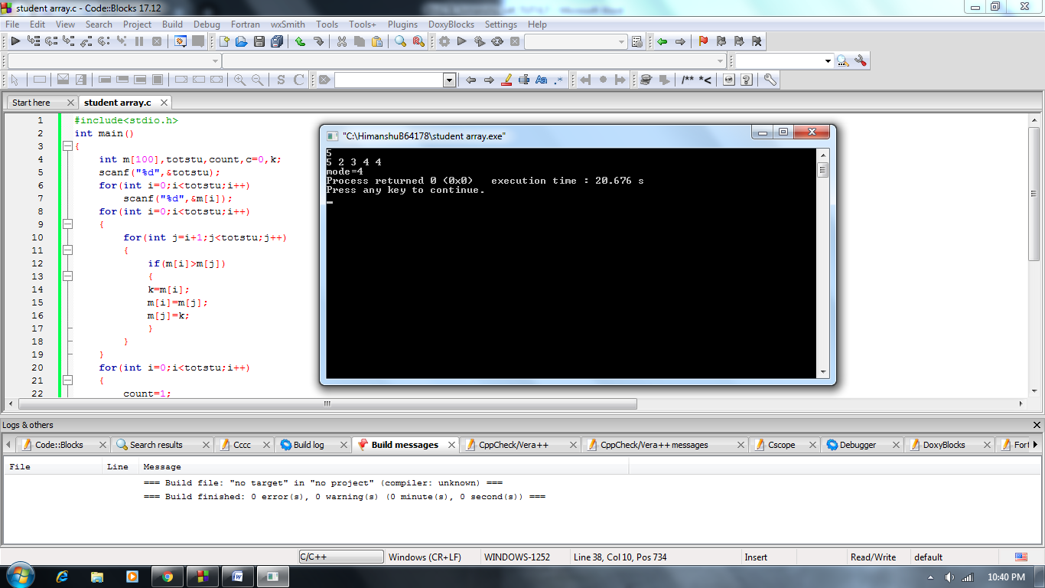

***f.*** *Create another array marks2 [] which stores the elements in marks[] array in non-decreasing order.*

**Solution:**

#include<stdio.h>

int main()

{

int m[100],totstu,m2[100],k;

scanf("%d",&totstu);

for(int i=0;i<totstu;i++)

scanf("%d",&m[i]);

for(int i=0;i<totstu;i++)

{

for(int j=i+1;j<totstu;j++)

{

if(m[i]>m[j])

{

k=m[i];

m[i]=m[j];

m[j]=k;

}

}

m2[i]=m[i];

}

for(int i=0;i<totstu;i++)

printf("%d ",m2[i]);

return 0;

}

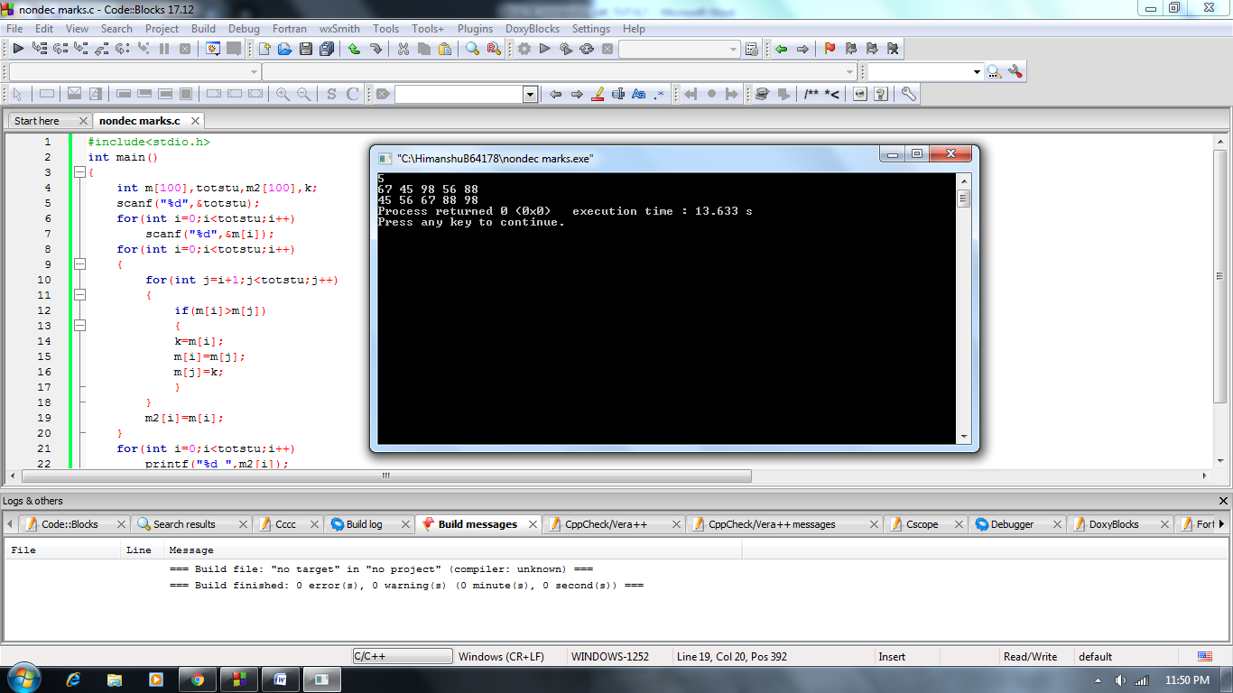

***g.*** *Create another array marks3 [] which stores the unique elements in marks [] array.*

**Solution:**

#include<stdio.h>

int main()

{

int m[100],totstu,m3[100],k;

scanf("%d",&totstu);

for(int i=0;i<totstu;i++)

scanf("%d",&m[i]);

for(int i=0;i<totstu;i++)

{

for(int j=i+1;j<totstu;j++)

{

if(m[i]>m[j])

{

k=m[i];

m[i]=m[j];

m[j]=k;

}

}

}

k=0;

for(int i=0;i<totstu;i++)

{

if(m[i]!=m[i+1])

{

m3[k]=m[i];

k++;

}

}

for(int i=0;i<k;i++)

printf("%d ",m3[i]);

return 0;

}

